User on checkout form and filled only name and credit card details - partial form

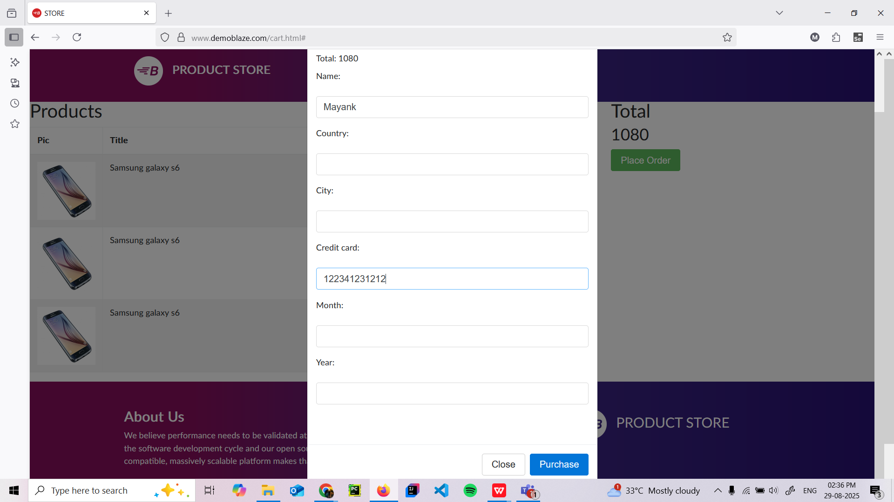

Purchase successfull card is shown with id, amount, card number, name, date

